**Introduction**



* User research is often the first step of a UX design process. You cannot start designing a product or service before understanding what the users want.
* Once you know the best practices in user research, it will help you gain first-hand knowledge of your users to design an optimal product— the one that sells better than your competitors’. So, here we go!

**User Research Techniques**

We do not recommend conducting user research without users. However, owing to budget and timescale constraints, it is quite common for service organizations to perform user research without involving users. The following techniques are adopted:

#With Users

* Requirements Capture Workshops
* Contextual Interview
* Usability Testing

#Without Users

* Stakeholder Interview
* First-click Testing
* Benchmarking
* Expert Review

**Requirements Capture Workshops**



Requirements gathering is an important step before commencing with the design. Prioritizing needs and wants is key here. The following steps are involved:

1. **Gather data from users**: Do not restrict your definition of users to the actual users of your product. Instead, widen the scope to include a sample that represents each stakeholder.
2. **Analyze data to understand user needs**: Use statistical techniques to optimize your data into manageable chunks. This will make it easier to analyze and derive insights.
3. **Convert user needs into requirements**: Once you complete the steps mentioned, it is pretty straightforward to elicit requirements from the hierarchical task analysis. You can then make a list of functional and non-functional requirements.

**Contextual Interview**

In a contextual interview, you observe and listen as the user works. You don't usually offer the tasks or scenarios.

**Contextual interviews** combine observations with interviews. By involving the user, you understand the user's environment and the actual technology the user works with. As opposed to usability testing, you watch people’s behavior in their environment doing their own tasks.

**Usability Testing**

Usability testing comes in many forms - casual coffee-shop studies, formal lab testing, remote online task-based studies and more. Irrespective of how you carry out your testing, you’ll need to go through these five phases:

**Prepare the Design or Product to Test**

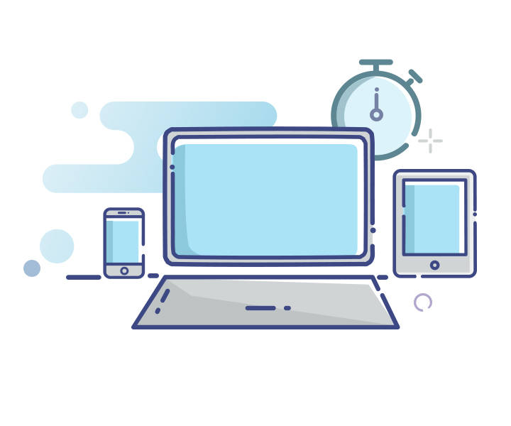

* Prepare your product or design to test
* Find your participants
* Write a test plan
* Take on the role of moderator
* Present your findings
* Prepare a set of goals for your study.
* Be specific. You will use these goals to frame study tasks.
* You will need to figure a way to illustrate your designs for the study. For initial design ideas, you can use a paper 'prototype' from pencil sketches or design it through software such as PowerPoint.

**Find your Participants**



* Identify potential users for your product and find how you can reach them.
* Test with relevant users, make improvements, test again and make further improvements.
* Appreciate the participants' time by offering incentives either in the form of cash or gift cards. The going rate may vary in different parts of the world.

**Write a Test Plan**



* A test plan will enable smoother communication with stakeholders and design team members who may want input into the usability test and, of course, keep yourself on track during the actual study days.
* This is a place for you to keep a record of all the details of the study.

**Take on the Role of Moderator**



* As a moderator, make sure the sessions go well and the team gets the information they need to enhance their designs.
* Participants should be made comfortable while they proceed through the tasks. You must look forward to minimizing or managing any technical difficulties and observer issues. Always stay neutral.

**Present your Findings**

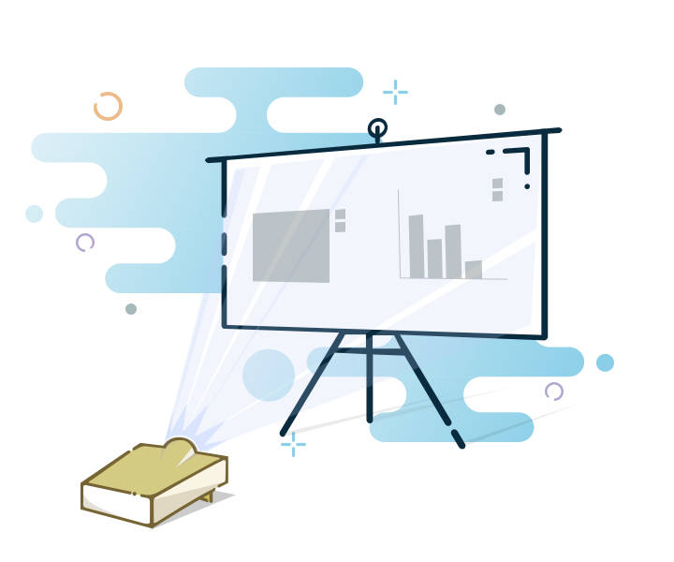

* Jot down themes you notice, especially if they’re related to the study’s goals.
* It's a good idea to talk to observers after each session to get a sense of their main learnings.
* Once the sessions are over, look for more answers to the study’s stated goals, and count how many participants acted differently or made certain types of comments.
* Determine the best way to communicate this information to help stakeholders.

​

**Stakeholders Interview**



* A **stakeholder** is anyone with an interest in the project's output. They can be anyone from customers, bosses, subordinates to peers both within and outside the organization. The conversations are conducted with any of the mentioned stakeholders.
* These interviews allow you to step into the shoes of your interviewees and understand their perspective.
* A useful way to get the business’ input into your project is through a **UX Stakeholder interview**.

**Benchmarking**



Benchmarking studies measure your baseline. It also helps to track how the design and functional changes impact the user experience. Two main ways to benchmark - Stand-alone benchmarking and Competitive Analysis.

* **Stand-alone benchmarking**: Also known as *Usability benchmarking*, it helps to establish the starting point to track how the user experience is impacted by your design iterations.
* **Competitive analysis**: It helps generate ideas. Assessing multiple websites gives you insights on what works and what doesn’t, to make sound design decisions.

**Expert Review**



An expert review is where usability experts use their knowledge and experience to walk through a product in the shoes of a typical user. Experts will spot problems and recommend changes to improve usability. We prefer expert reviews when budgets and timescales don’t allow for user research.

##### Global and Cross-Cultural Research Techniques

Cross-cultural research techniques have been gaining prominence. Offering a product translated in 10 to 20 different languages is no longer sufficient. Users also want a product that acknowledges their unique cultural characteristics and business practices.

**Power Distance (PDI)**

According to Geert Hofstede, **Power Distance Index (PDI)** measures the extent to which the less powerful members of organizations and institutions (like the family) accept and expect that power is distributed unequally. It suggests the degree of society’s level of inequality endorsed by the followers as much as by the leaders.

* *People who come from societies with a small power distance do not prefer to be controlled*. Communication with this group can be kept informal, direct, and in a participative way to gain their trust and to engage them. Meet your website visitors on eye-level, respect them, and take an interest in their needs.
* *People from societies with a big power distance are used to authorities and solid structures*. People consider you as an expert and trust you as an authority figure. Ensure you provide facts and clear statements upfront and don’t load your visitors with a lot of responsibility. People who visit your website from this group are slightly less critical and less driven to search for detailed information to make up their mind.

**Individualism versus Collectivism**

* People from societies with a high score on **individualism** are those who take the initiative to act on their needs and desires and make their own decisions. They visit your site out of interest, to realize their own goals and make their own decisions. You need to focus on these individual requirements to convert them into loyal customers.
* On the other hand, people who belong to a **collectivist** culture consider the interest of the group first, rather than their own interest. Consider this on your web portal and offer enough reference points, such as testimonials, 'popular' categories, or social media sharing options to gather feedback from peers.

**​Uncertainty Avoidance (UAI)**

* 

* + People from societies with a *high Uncertainty Avoidance (UAI)*, prefer deductive rather than inductive approaches. They think over, make decisions and take actions based on a systematic evaluation of all available and relevant aspects.
  + People from societies with a *low Uncertainty Avoidance* are more open to new ideas, they are willing to try something different, and have a good risk-taking appetite. They are more tolerant of new ideas and opinions even if the ideas differ from their own.

**Long-Term versus Short-Term Orientation (LTO)**



* + People with **short-term orientation** focus more on the past and present than on the future. They prefer quick results that are in line with known values and traditions.
  + People with **long-term orientation** make accurate decisions for the future. These users have to be offered detailed information and advantages that truly convince them of your product's value.

**Task Analysis**



* When specifying or designing a feature, it is essential that you understand the tasks which the users must perform, including the situation in which they carry out the tasks.
* In task analysis, we interview end users and observe them while they perform their work in context.
* During final analysis, each task supported by the product is listed along with the associated steps needed for completing the task, step inputs and outputs, and the surrounding context in which the task is performed.

**Surveys and Questionnaires**



* These are quantitative modes of research and offers a quick way to collect information from a large number of users.
* The obvious limitation here is lack of any interaction between the researcher and the users.

**Card Sorts**

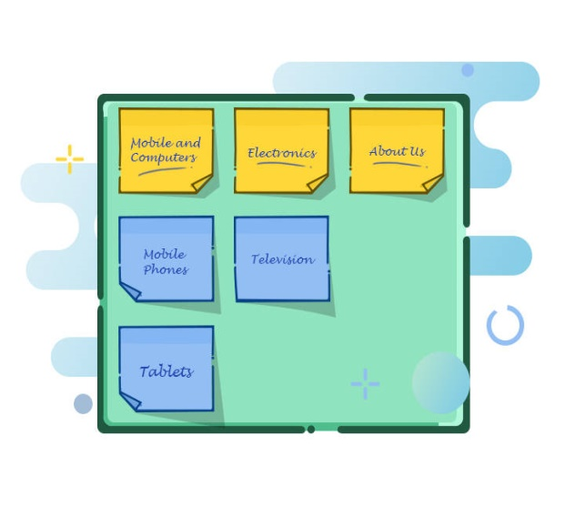

The primary goal of a card sort test is to understand how users perceive relationships and hierarchies between various content, categories and other information. This is typically used to generate information architecture or site maps.

**Tree Tests**

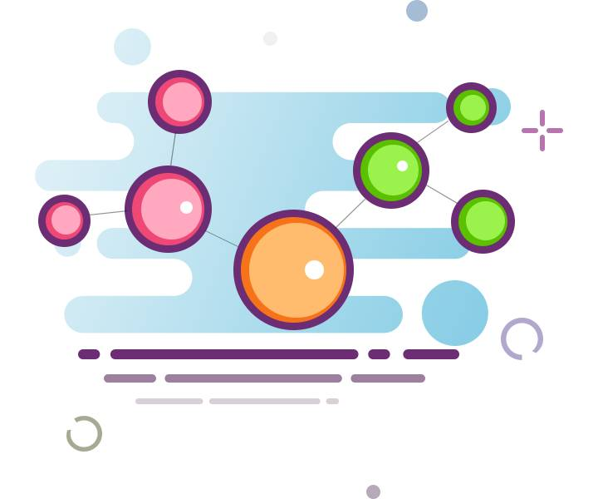

**Tree testing** is a usability technique to evaluate the findability of topics in a website. It is also known as *reverse card sorting* or *card-based classification*.

Similar to card sort, the primary goal here is to test whether the product has the appropriate level of information hierarchy designed within the product.

**A/B Tests**

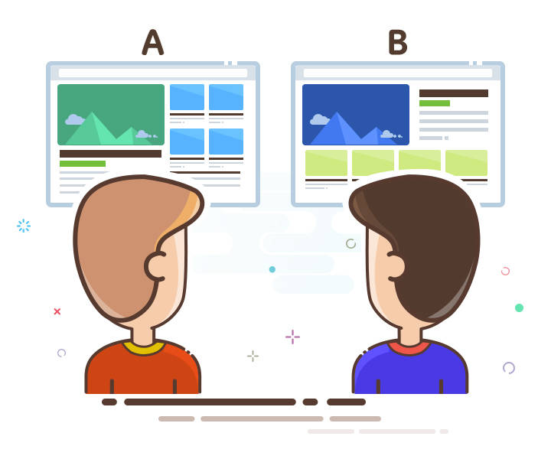

* A/B testing, also known as split testing, compares two versions of a web page to see which one performs better.
* It focuses on providing similar users with two or more options and documenting the user’s preferences amongst the options.
* There are also focused A/B tests on specific aspects of the product such as the design elements, information hierarchy, navigation and so on.

**Storyboard**

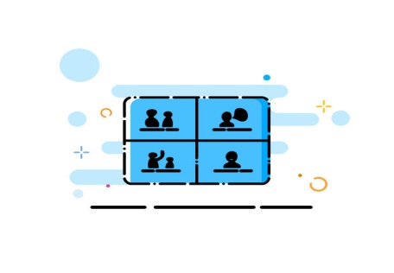

**Storyboards** are illustrations that represent shots which ultimately represent a story. It’s a sequential art where we array the images together to visualize the story. This method came from the motion picture production

**User Persona**



It is a fictitious representation of a group of users who exhibit a similar pattern regarding the behavior of using the application regardless of age, gender, location, education, and profession.

**Reporting on User Research**

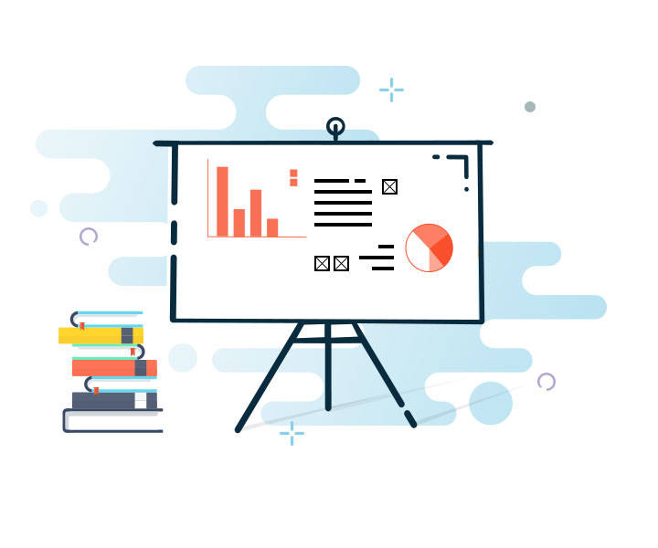

There are various types of deliverables—from no deliverable at all to a full report. It is highly advisable that you choose a deliverable that allows you to share your research findings and recommendations in the available timeframe and considers the needs of your audience.

**No Deliverable**

* If you involve the right people throughout the research, you may just need to have a discussion on your findings and make changes to the design without spending any time creating a deliverable.
* However, keep in mind that you will have no record of your findings for later use.

**Quick Findings**

If time is a constraint, your deliverable can be in the form of an **email** or **a document ** which describes your overall findings and proposed design changes.

**Detailed Reports**

A report gives you the freedom to describe your findings and recommendations comprehensively and in as much detail as needed. Reports have value as proof of the research.

**Presentations**

When your deliverable is a presentation, you need to optimize it for effective delivery. Those who view it later should be able to understand it easily, without the explanations you initially give during your presentation.

**Findings and Recommendations Matrix**

A **Findings and Recommendations matrix** gathers all recommendations together. This is usually in a simple tabular format, summarizing the findings that led to each recommendation and if applicable, a severity rating for each issue.

**Course Summary**

Some of the key takeaways from this course are:

* User Research techniques with users
* User Research techniques without users
* Cultural factors to consider while designing an interface
* Qualitative techniques used for User Research
* Reporting User Research Findings